# Introduction

The "Auto Intensity Control of Street Lights" project is a smart and energy-efficient solution for urban and rural areas to optimize street lighting. This project utilizes the power of Arduino Nano, a Light Dependent Resistor (LDR), a DS3231 Real-Time Clock (RTC) Module, and LEDs to create a system that automatically adjusts the intensity of streetlights based on ambient lighting conditions. This intelligent system ensures that streetlights are bright enough during the night and dim during daylight, saving energy and reducing operational costs.

Benefits of Auto Intensity control of Street Lights are Energy Efficiency, Environmental Impact, Maintenance Savings, Improved Safety, Smart and Reliable.

The "Auto Intensity Control of Street Lights" project is a testament to the power of modern technology in creating more sustainable and efficient urban infrastructure. By using Arduino Nano, LDR, DS3231 RTC Module, and LEDs, this system not only saves energy and money but also contributes to a greener and safer environment.

## **Literature survey**

[1] AUTHORS: Deepu vijay M, Kamlesh shah and Bhim Singh, “LED BASED STREET LIGHTHING WITH AUTOMATIC INTENSITY CONTROL USING SOLAR PV”, petroleum and chemical industry conference (ICPSPCIC), 2015

The above mentioned technical parer signifies that the project uses LDR for measurement of light, buckboost converter to control the intensity of light and powered by solar power.

[2] AUTHOR: Tejaswini Ankalkote, “MODERN STREET LIGHTING SYSTEM WITH INTENSITY CONTROL BASED ON VEHICLE MOVEMENT AND ATMOSPHERIC CONDITION USING ZIGBEE”, 2018 international conference on information, communication engineering and technology (ICICET), August 2018The above mentioned project uses LDR for measurement of surrounding light intensity and the intensity of the street light is automatically controlled using IRFS20 MOSFET configured with Arduino UNO.

[3] AUTHORS: Geethika kilari, Rizwan Mohammed and Jayaram, “AUTOMATIC LIGHT INTENSITY CONTROL USING ARDUINO UNO AND LDR”, International conference on Communication and Signal processing, India, 28-30 JULY 2020.The above mention project uses photoresistor and Zigbee for sensing surrounding light intensity and vehicle movment, the intensity of the streetlight is controlled based on the vehicle movment.

# Our project signifies auto intensity control of street lights based on surrounding lighting conditions with being economical and energy efficient.

**Objectives of the mini project**

The Objectives of the mini project are mentioned here:

1. Automatic control of street light intensity
2. Efficient usage of electricity
3. To develop prototype to prove the concept

To achieve these objectives, a typical auto intensity control system for street lights might employ various sensors like light sensors, a microcontroller to intelligently control the brightness of the streetlights. This system can be designed to dim or turn off streetlights during daylight and brighten them when required, such as during nighttime.

Ultimately, the project aims to create a sustainable, cost-effective, and environmentally friendly solution for street lighting that can benefit both the community and local governments.

Problem statement:

Sometimes the street lights are in ON state during ambient lighting conditions, which causes lots of energy to go in waste and maintaining intensity of street lights automatically is a solution to control misuse of energy. To prevent this wastage of energy we have created a auto intensity control based street light whose brightness increases or decreases based on the ambient surrounding light with flexibility of manual control and save lots of energy.

**BLOCK DIAGRAM**:

The block diagram of the "Auto Intensity Control of Street Lights" system consists of essential components for automated lighting control. It starts with a Light Dependent Resistor (LDR) sensing ambient light levels. The LDR sends data to an Arduino Nano, the central control unit. The system also includes a DS3231 Real-Time Clock (RTC) module for accurate time tracking. The Arduino processes data from the LDR and RTC and controls the LEDs accordingly. During nighttime, when the LDR detects low light and the RTC indicates nighttime, the Arduino increases LED intensity. During daylight, it decreases the LED intensity or turns them off, thus optimizing energy consumption.

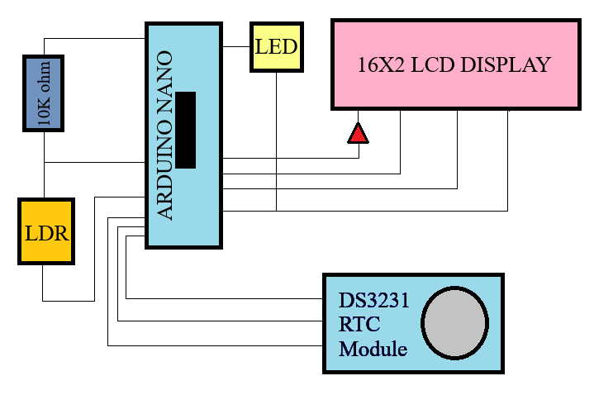

Fig. 1: Block-diagram of the Auto Intensity control of lights

1. Arduino Nano is the microcontroller (MCU) used in project.
2. DS3231 RTC Module is the time piece.
3. LDR is photo resistor which changes resistance based on light intensity
4. LED emits light
5. LCD displays input

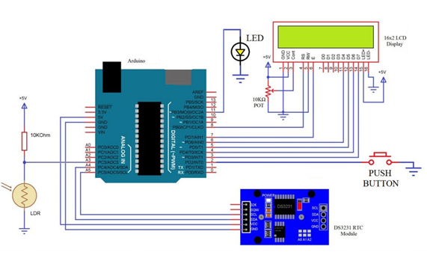

Fig. 2: Circuit Diagram

This street light control project uses an Arduino Nano, DS3231 RTC module, LDR, LED, and a 16x2 LCD display. The circuit design begins with the LDR sensing surrounding light intensity, sending this analog data to the Arduino Nano. Simultaneously, the DS3231 RTC module provides accurate time data. The Arduino processes these inputs and adjusts LED brightness levels dynamically, depending on surrounding intensity. The 16x2 LCD display shows real-time information. When low intensity is detected, the LED illumination increases, and vice versa, ensuring energy-efficient street lighting that adapts in real-time to changing environmental conditions.

**ALGORITHMS:**

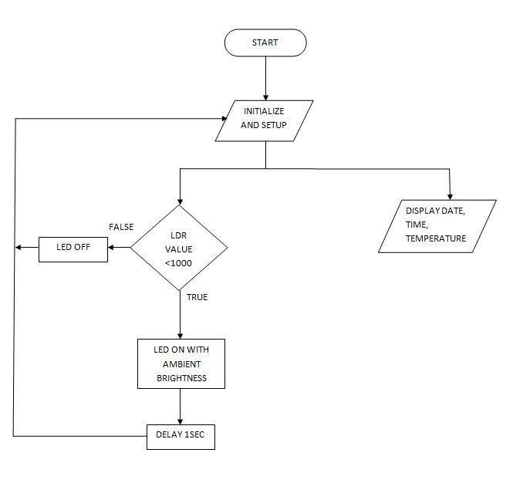

Fig. 3: Flowchart of the Auto Intensity control of lights

**Step 1:** Initialize and setup

- Initialize the values of LDR readings of surrounding intensity and RTC readings for current date and time and Set up the Arduino Nano, DS3231 RTC module, LDR, LED, and 16x2 LCD display.

**Step 2:** Configure LCD Display

- Initialize and configure the 16x2 LCD display to show real-time data.

**Step 3:** Determine Surrounding Intensity

- Depending on the LDR reading, decide the surrounding light intensity (bright, moderate, or low).

**Step 4:** Control LED Brightness

- Based on the surrounding intensity, adjust the LED brightness:

- If it's bright, set the LED to low brightness or turn it off.

- If it's moderate, set the LED to medium brightness.

- If it's low, set the LED to full brightness.

**Step 5:** Display Information

- Show real-time data on the LCD display, including LDR reading, time, and LED brightness level.

**Step 6:** Repeat

- Continuously repeat Steps to maintain dynamic control of streetlight intensity.

**Step 7:** End

- The system continues to operate, adapting LED brightness depending on the surrounding intensity, ensuring efficient and adaptive street lighting.

This algorithm ensures that the streetlights automatically adjust their brightness based on real-time environmental conditions, making them energy-efficient and responsive to changing light levels.

**WORKING PRINCIPLE:**

The "Auto Intensity Control of Street Lights" project is designed to intelligently adjust streetlight brightness based on the surrounding light intensity, providing efficient and responsive illumination. Here's a detailed working principle for the project:

1. Light Sensing with LDR:

The project begins with a Light Dependent Resistor (LDR) serving as the light sensor. The LDR continuously measures the intensity of ambient light. As the amount of available natural light changes throughout the day and night, the LDR's resistance varies accordingly. During daylight, the LDR's resistance is high due to ample light, and at night, it becomes low due to reduced light.

1. Real-Time Clock (RTC) Module:

Simultaneously, a DS3231 RTC module provides precise timekeeping data to the system. This module ensures that the system operates with temporal accuracy, enabling it to adapt to changing lighting requirements throughout the day and year, such as during twilight or varying sunrise and sunset times.

1. Arduino Nano Control:

The heart of the system is the Arduino Nano microcontroller. It acts as the decision-maker, processing data from both the LDR and RTC module. It constantly monitors the LDR's resistance and compares it with a predefined threshold value. If the LDR resistance falls below the threshold, indicating low surrounding light, the Arduino takes action.

1. LED Brightness Adjustment:

Depending on the LDR's reading and the current time from the RTC module, the Arduino controls the brightness of the connected LEDs. If it's dark, the LEDs illuminate at a higher intensity, ensuring proper street lighting for safety. During daylight or higher ambient light conditions, the Arduino dims the LEDs or turns them off entirely to save energy.

1. LCD Display (16x2):

To provide user feedback and real-time status, a 16x2 LCD display is often incorporated. It shows information such as the current time, ambient light status, and LED brightness level, allowing users to monitor the system's operation.

This dynamic and intelligent system not only optimizes energy consumption but also enhances safety by ensuring that streetlights are bright when needed and dim when sufficient natural light is available, contributing to a more sustainable and cost-effective urban infrastructure.

**Hardware/ Software tools Used**

**Hardware:**

The hardware that is used for ‘The Auto Intensity Control of Street lights’ are

1 Arduino Nano: The Arduino Nano serves as the central control unit, orchestrating the automatic adjustment of streetlight intensity based on surrounding conditions.

2 LDR: The LDR (Light Dependent Resistor) is employed in this project to sense and measure ambient light levels, facilitating automatic adjustments in streetlight intensity based on surrounding illumination.

3 DS3231 RTC Module: The DS3231 RTC module is used to provide accurate time data, enabling precise control of streetlight intensity adjustments based on real-time conditions.

4 LED: They are used for their energy efficiency and controllable brightness levels in this project, ensuring adaptive and efficient street lighting.

5 16X2 LCD Display: The 16x2 LCD display provides real-time status information and user feedback, enhancing system monitoring and control for the Auto Intensity Control of Street Lights project.

**Software:**

Arduino IDE:

In this project, the Arduino IDE (Integrated Development Environment) is used to write, compile, and upload the code to the Arduino Nano, facilitating seamless programming and control of the streetlight system. It serves as the programming hub for configuring the system's logic and behavior.

**Results and Discussions**

The system first analyses the amount of light present in the surrounding area with the help of LDR readings, depending on the surrounding lighting conditions LED adjusts its intensity in ON state or remains in OFF state.

The auto intensity control system has been designed for scheduled ON and OFF with auto and manual control.

**Photographs:**

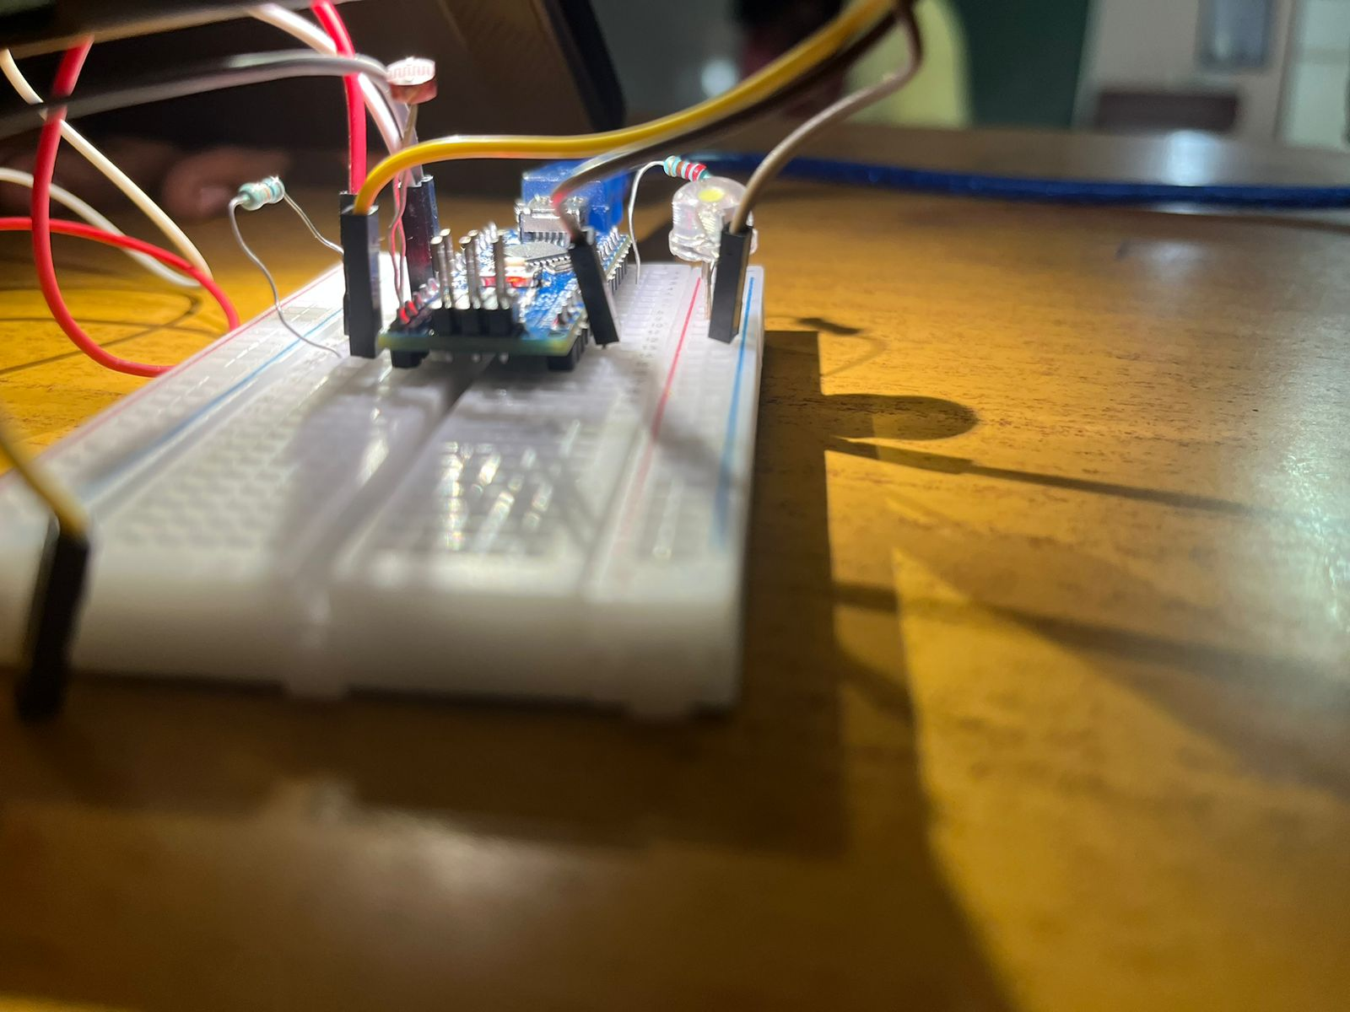

Fig. 4: output of LED in ‘OFF’ state due to ambient surrounding light

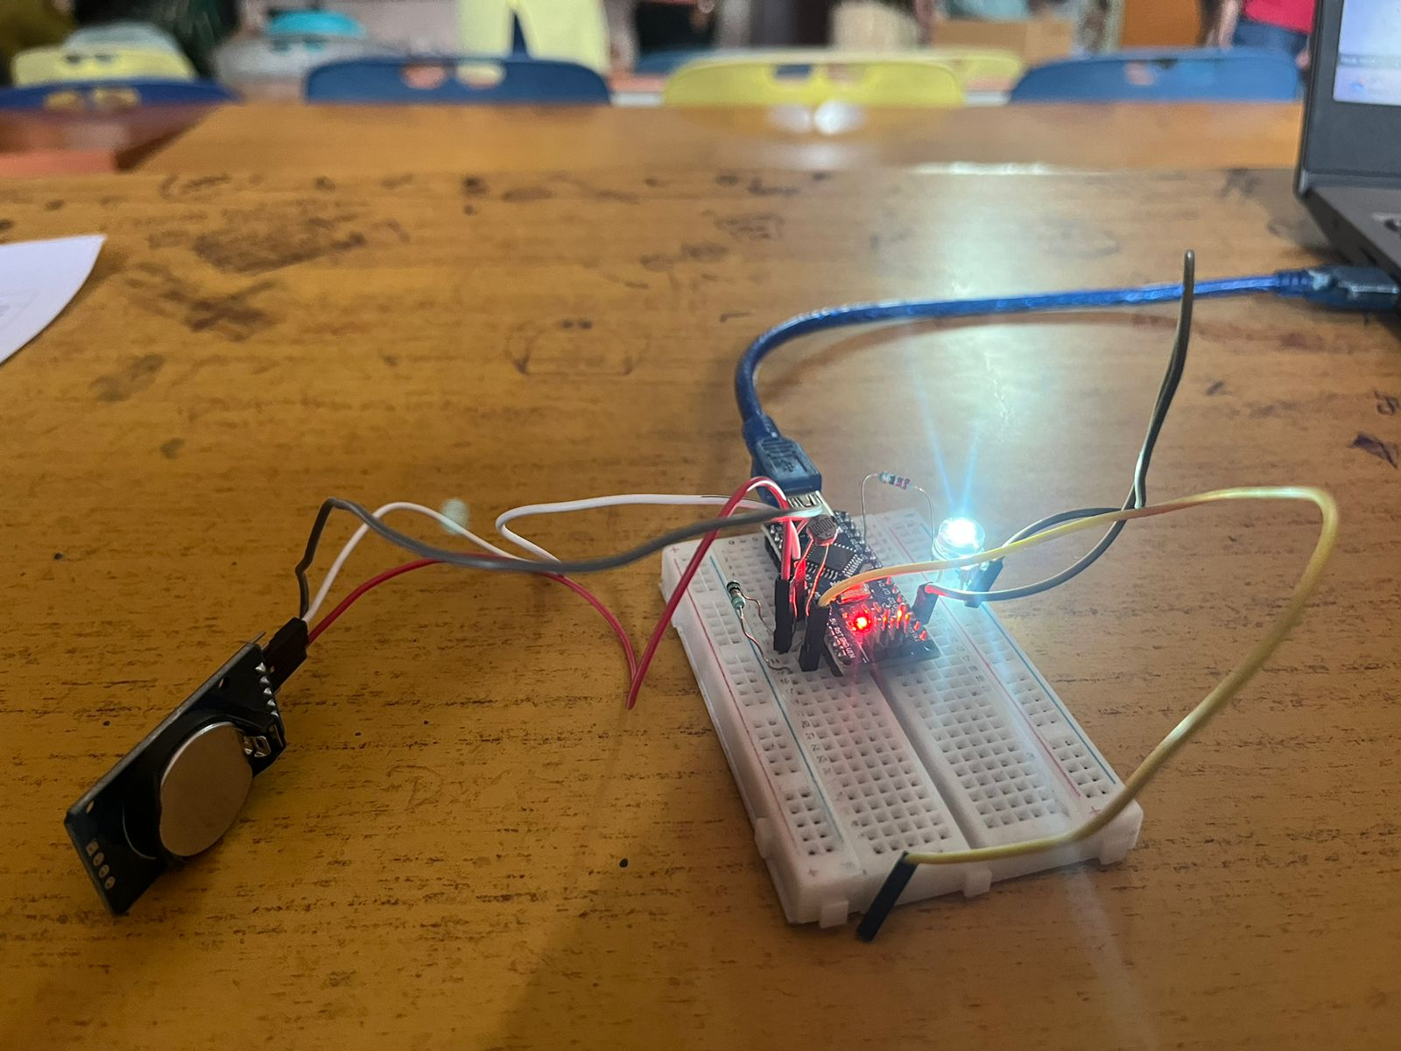

Fig. 5: output of LED in ‘ON’ state due to ambient surrounding light

**Advantages**

1. Energy Efficiency: Reduce energy consumption and carbon footprint by ensuring that streetlights operate at full intensity only when necessary.

2. Economical: Decrease electricity costs for street lighting, which can be a significant expense for municipalities.

3. Enhanced Safety: Ensure that streets are adequately illuminated during low light conditions to enhance safety for pedestrians and drivers.

4. Adaptability: Create a system that can adapt to changing environmental conditions, such as varying light levels due to weather or time of day.

5. Remote Monitoring: Allow for remote monitoring and control of streetlight brightness, making it easier for maintenance and troubleshooting.

6. Reduced Light Pollution: Minimize light pollution by ensuring that streetlights are not excessively bright during low traffic or nighttime hours.

**Applications**

The major applications of auto intensity control of street lights are Energy-Efficient Street Lighting, Enhanced Safety, comprehensive street lighting infrastructure, Manual Control, Reduced energy consumption, Cost Savings and Smart Cities.

Overall, this project offers a holistic solution for energy-efficient, cost-effective, and environmentally friendly street lighting. It combines automation, scheduling, manual control, and real-time monitoring to create a system that benefits both municipalities and the community at large.

# Conclusions

In conclusion, the "Auto Intensity Control of Street Lights" project represents a sophisticated and environmentally conscious solution for efficient **street lighting. T**his project achieves a highly responsive and versatile lighting system that not only adapts to the surrounding light intensity but also incorporates scheduled on/off functionality and manual control.

**References**

1) AUTHORS: Deepu vijay M, Kamlesh shah and Bhim Singh, “LED BASED STREET LIGHTHING WITH AUTOMATIC INTENSITY CONTROL USING SOLAR PV”, petroleum and chemical industry conference (ICPSPCIC), 2015

2) AUTHOR: Tejaswini Ankalkote, “MODERN STREET LIGHTING SYSTEM WITH INTENSITY CONTROL BASED ON VEHICLE MOVEMENT AND ATMOSPHERIC CONDITION USING ZIGBEE”, 2018 international conference on information, communication engineering and technology (ICICET), August 2018

3) AUTHORS: Geethika kilari, Rizwan Mohammed and Jayaram, “AUTOMATIC LIGHT INTENSITY CONTROL USING ARDUINO UNO AND LDR”, International conference on Communication and Signal processing, India, 28-30 JULY 2020

# Appendix

Hardware Description: The core hardware components include a micro-controller unit (MCU), commonly an Arduino or Raspberry Pi, for processing data and controlling the system. A Light Dependent Resistor (LDR) or other light-sensing device detects ambient light levels. A relay module is used to control the streetlights. Additionally, there's a real-time clock (RTC) module for precise timekeeping. Power is typically supplied by the local grid, and a voltage regulator ensures stable operation.

Software Description: The software component employed is ARDUINO IDE and it consists of an algorithm running on the Arduino. It continuously reads data from the LDR, calculates the ambient light level, and determines whether streetlights should be turned on, dimmed, or turned off. Time-based scheduling is often incorporated to ensure lights are active during the night. The Arduino also adjusts lighting intensity dynamically, reducing it during low-traffic hours to save energy. Communication software enables remote monitoring and control through a dedicated app or web interface. Moreover, data logging capabilities can be integrated to analyze energy consumption patterns and optimize lighting schedules further. This software-hardware synergy creates an energy-efficient and automated street lighting system.